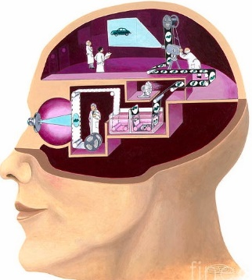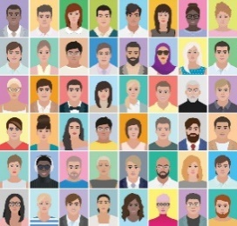

Capture Live Video

Data Preparation

Object or Face Detection RPN

Feature Extraction using LBP

Classification using CNN

Build and Train



Prediction

Known Person Name

Unknown Age Gender Exp

**Face Enrollment**

**Object Dataset**

**Artificial Vision: Build and Train**

Import Dataset

Face

Age

Gender

Expression

Deploy Model

Spatial Distance

Object Name

**Live Video**

Audio Output